


Web Scraping and Analysis
Analyze Hotels in Egypt



Prepared By
Yahya Mahmoud Zakaria 23011619
Yousef Ahmad Mohamad 23011623
Yahya Mustafa Mohamad 23011620
Hamed Abdelrahman Saad 23011248
Ahmad Rashad Elsayed 23011204

Prepared On
28/4/2025



GitHub Link
https://github.com/yahia997/Scrapping-Project

Website
We chose https://booking.com as our destination of data.

Pipeline
We followed ETL pipeline as developers do in real world projects. So that we make Load MongoDB first then we extract from it using MQL queries and make visualizations and analytics on it. If data is Loaded at the final stage then the data is for achieving.
Scrapping
Data analysis and visualization
Load to MongoDB
Data Preprocessing

Deploy to Streamlit

Data Extraction (Scrapping) [Yahya Mahmoud]
I used selenium with beautifulSoup to scrap the website. Selenium to be able to interact with the page such as click on buttons and to imitate user behavior to as a bot to get the “price” Field (can not be extracted with bs4).
Attribute | Information (Example)
Hotel Name | Four Seasons Hotel Alexandria At San Stefano
Location. | 399 El Geish Road , San Stefano, 21599 Alexandria, Egypt
Description. | More info about the hotel
facilities | - 3 swimming pools (1 open)  - Spa  - Fitness center  - Restaurant (temporarily closed)
Comments | "name": "…",  "country": "…",  "description": "…"
Number of reviews | 5000
Rating | From 0 to 10
rating_details | "Staff ": "8.7",  "Facilities ": "8.1",  "Cleanliness ": "8.3",  "Comfort ": "8.3",  "Value for money ": "7.7",  "Location ": "9.0",  "Free Wifi ": "7.3"
longitude and latitude | (31.231793499770284,29.94602680206299)
Url | Link to the hotel page to be able to return to it again for updates for example
Price | “Starts from price” for the hotel

We will get data about hotels in Egypt in the following cities:

Alexandria

Cairo

Hurghada

Sharm El Sheikh

Ain Sokhna

Dahab

Port Said

North Coast

Fayoum

Aswan

Marsa Alam

Ismailia
I used BFS approach to get lots of data about many hotels in different cities, Then used CSS selectors to grab deeply nested elements to get data from. For example,
'div div div:nth-child(1) div div:nth-child(2) div:nth-child(2) span'

This is an object from what we git:
{
"title": "Serry Beach Resort",
"url": "https://www.booking.com/hotel/eg/serry-beach-resort.html?label=gen173nr-1FCAEoggI46AdIM1gEaEOIAQGYATG4ARfIAQzYAQHoAQH4AQKIAgGoAgO4AuHX6b8GwAIB0gIkNWQ1YjkzZWYtMmFmMy00ZjNmLWJhYTItNzE5ZjdkMmNkNDQy2AIF4AIB&aid=304142&ucfs=1&arphpl=1&checkin=2025-04-12&checkout=2025-04-13&dest_id=-290029&dest_type=city&group_adults=2&req_adults=2&no_rooms=1&group_children=0&req_children=0&hpos=2&hapos=2&sr_order=popularity&srpvid=f10c684cab0f06df&srepoch=1744469395&all_sr_blocks=1006733303_375845967_2_1_0&highlighted_blocks=1006733303_375845967_2_1_0&matching_block_id=1006733303_375845967_2_1_0&sr_pri_blocks=1006733303_375845967_2_1_0__38500&from_sustainable_property_sr=1&from=searchresults",
"price": "EGP 1,294",
"address": "27.187356614148406,33.83184586779785",
"description": "Well located in Hurghada, Serry Beach Resort provides air-conditioned rooms, an outdoor swimming pool, free WiFi and a fitness center. With a private beach area, the property also features a terrace, as well as a bar. The property has a kids' club, room service and currency exchange for guests.\n\nAt the hotel, each room is equipped with a closet. Each room has an electric tea pot and a private bathroom with a shower and free toiletries, while selected rooms come with a kitchenette equipped with a microwave. Guest rooms at Serry Beach Resort are equipped with a flat-screen TV with satellite channels and a safety deposit box.\n\nThe breakfast offers buffet, continental or Full English/Irish options. At the accommodation you'll find a restaurant serving African, Middle Eastern and Seafood cuisine. Vegetarian, halal and gluten-free options can also be requested.\n\nSerry Beach Resort has a playground. You can play pool, table tennis, and darts at the 5-star hotel.\n\nSpeaking Arabic, German, English and French, staff at the reception can help you plan your stay.\n\nPopular points of interest near the hotel include Albatros White Beach, Marina Sports Club Beach and Old Vic Beach. Hurghada International Airport is 1.2 miles away, and the property offers a paid airport shuttle service.",
"address2": "3, Touristic Villages, Hurghada 3, Touristic Villages, Hurghada, 84511 Hurghada, EgyptExcellent location – rated 9.3/10!(score from 304 reviews)Real guests • Real stays • Real opinions",
"facilities": [
"Outdoor swimming pool",
"Free Wifi",
"Airport shuttle",
"Beachfront",
"Family rooms",
"Spa",
"Fitness center",
"Bar",
"Private beach area",
"Good Breakfast",
"Outdoor swimming pool",
"Free Wifi",
"Airport shuttle",
"Beachfront",
"Family rooms",
"Spa",
"Fitness center",
"Bar",
"Private beach area",
"Good Breakfast"
],
"reviews_cnt": "304 reviews",
"rating": "Scored 8.8 ",
"rating_details": {
"Staff ": "8.8",
"Facilities ": "9.0",
"Cleanliness ": "9.2",
"Comfort ": "9.2",
"Value for money ": "8.3",
"Location ": "9.3",
"Free Wifi ": "9.4"
},
"comments": [
{
"name": "Deni United States“We had a lovely stay at Serry Beach Resort. The property is beautiful, with a stunning pool and beach that made for the perfect relaxation spot. The atmosphere was peaceful, and the staff were friendly and welcoming. We truly enjoyed our time here...”Read more",
"country": " United States",
"description": " United States"
},
{
"name": "Pinky-traveladdict Norway“The service was top, and everyone was happy and friendly.\nFatima at the reception went out of her to see that we get the best room.\nThere was a variety of food dishes, so many options to choose. The best part was late breakfast and lunch for those...”Read more",
"country": " Norway",
"description": " Norway"
},
{
"name": "Kevwe France“I loved how clean this property was, the great food, the accommodating staff, the entertainment timetable, the large single beds that could comfortably fit in two people, the clean beach, the view from my room… I could go on and on”Read more",
"country": " France",
"description": " France"
},
{
"name": "Chuxuan China“Amazing location at the beach with beautiful long pool and sun chairs. Breakfast offers large variety and is tasty.”Read more",
"country": " China",
"description": " China"
},
{
"name": "Abdulrahman Turkey“One of the best resorts in Hurghada recommend it to everyone going there”Read more",
"country": " Turkey",
"description": " Turkey"
},
{
"name": "Qudsiyah United Kingdom“It was clean, beautiful, scenic, peaceful, aesthetic, vibes were immaculate and just amazing everywhere you looked.”Read more",
"country": " United Kingdom",
"description": " United Kingdom"
},
{
"name": "Yaro United Kingdom“We got upgraded to a room that was beach front and it was an amazing stay for us. Food was phenomenal”Read more",
"country": " United Kingdom",
"description": " United Kingdom"
},
{
"name": "Hassan Saudi Arabia“As my first experience in an all inclusive hotel I found the stay wonderful by all measures. The facilities were second to none especially in Egypt, the room was great, the food is incredible with huge variety. However what tops it all off and the...”Read more",
"country": " Saudi Arabia",
"description": " Saudi Arabia"
},
{
"name": "Mohammed Qatar“Serry beach resort is an exceptional resort with beautiful surroundings and top-notch amenities. The highlight of my visit was the outstanding service from our butler, Waleed and mohammed , who went above and beyond to ensure a perfect stay with...”Read more",
"country": " Qatar",
"description": " Qatar"
},
{
"name": "Menghan China“Amazing facility. Buffet 100%. Recommend to get the all inclusive. Special shoutout to Fatima at front desk and Yasser from food & beverage for professional and patient assistance”Read more",
"country": " China",
"description": " China"
}
]
}

Data Cleaning, preprocessing and Regular expressions
As our data in JSON format we will loop through each hotel and preprocess it rather than using pandas dataframe. We have nested object that we can not store and process in pandas such as comments list.
We will not use Spark RDDs as it is well suited for big data.

From the scrapped data we did the following to preprocess it and make it read to deploy:
    - "address":
separated longitude and latitude with regex. We have comma between them and set their data type to float.

- “address2”:
We make a list from cities we want to scape and check if this city belongs to this address or not as the “address2” does not have fixed schema.

We make country always equal to Egypt.

We removed all the unwanted text with regex after the country such as “EgyptExcellent location – rated 9.3/10!(score from 304 reviews)Real guests • Real stays • Real opinions” this pattern is repeated in a lot of objects.

    - "reviews_cnt":
We get the number of reviews and removed “reviews” keyword and comma from it with regrex and converted it to int datatype.
    - "rating":
We did the same thing as we did in “reviews_cnt”
    - "comments":
We noticed the following pattern:
“<name> <country>”<description>”Read more” and all that is merged in name attribute.
Ex:
"Deni United States“We had a lovely stay at Serry Beach Resort. The property is beautiful, with a stunning pool and beach that made for the perfect relaxation spot. The atmosphere was peaceful, and the staff were friendly and welcoming. We truly enjoyed our time here...”Read more"
- We split by comma so we git “<name> <country>” and ”<description>” and “Read more”
- Then we get name and country by splitting the first part by space and.
- The second part is the description.

    - "facilities":
We removed duplicates by putting it in a set and cast it to list again.
    - "description":
Removed extra <h2></h2> with regrex.
    - Remove duplicates from all data.
We checked that url is fetched before or not.
    - Handle missing data at all.
We filled missing Price with “Unknown”. Rating and rating_details with None.
    - Handle extra white spaces.
We strip fields such as description, country.

Load to MongoDB Atlas
We deployed before analysis to make any person capture data from any where and make his analysis (As in real projects).
We make that also to benefit from MongoDB Aggregation pipeline which will enable us make analysis more easily and faster (we will use python libraries If needed).

Firstly I chose Free Cluster on MongoDB atlas.
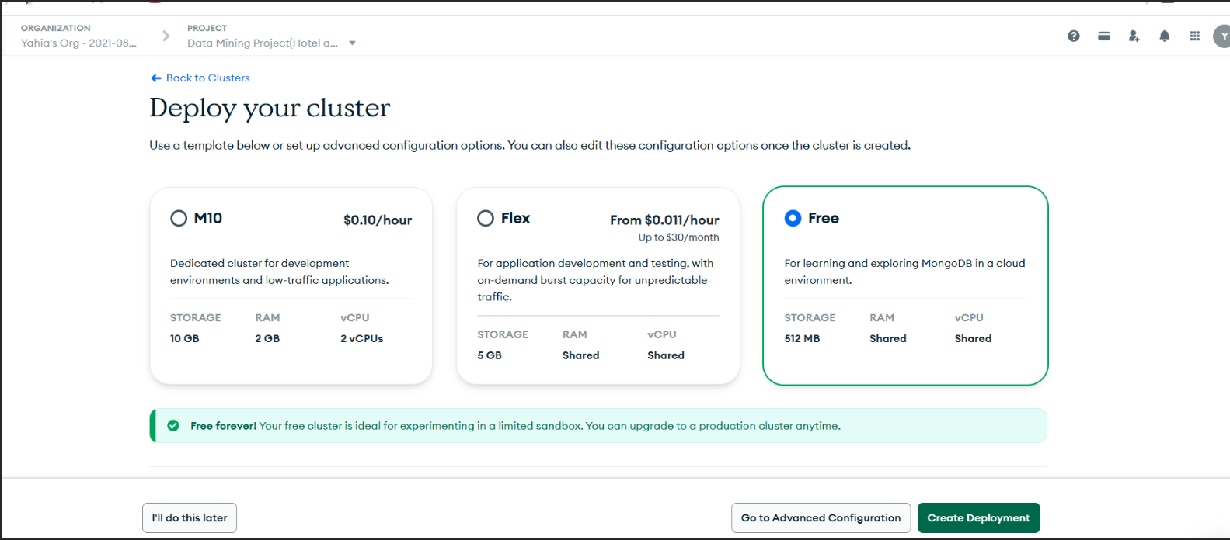
Then I created 2 users:
    - One with read and write privileges.
    - One with read privilege only to get data from MongoDB only.
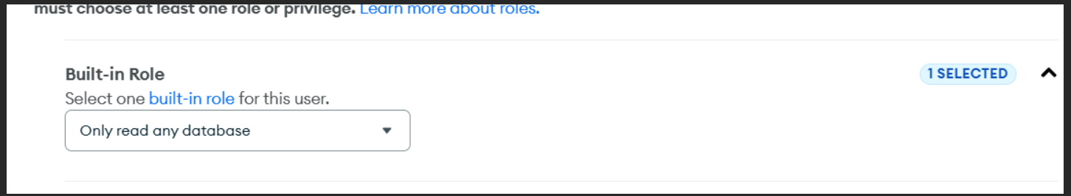

I created 2 Indexes to make queries faster for frequently-used queries:
    - On city.
    - On title.

Finally I set IP address to “0.0.0.0/0” to be global to access data from any device.
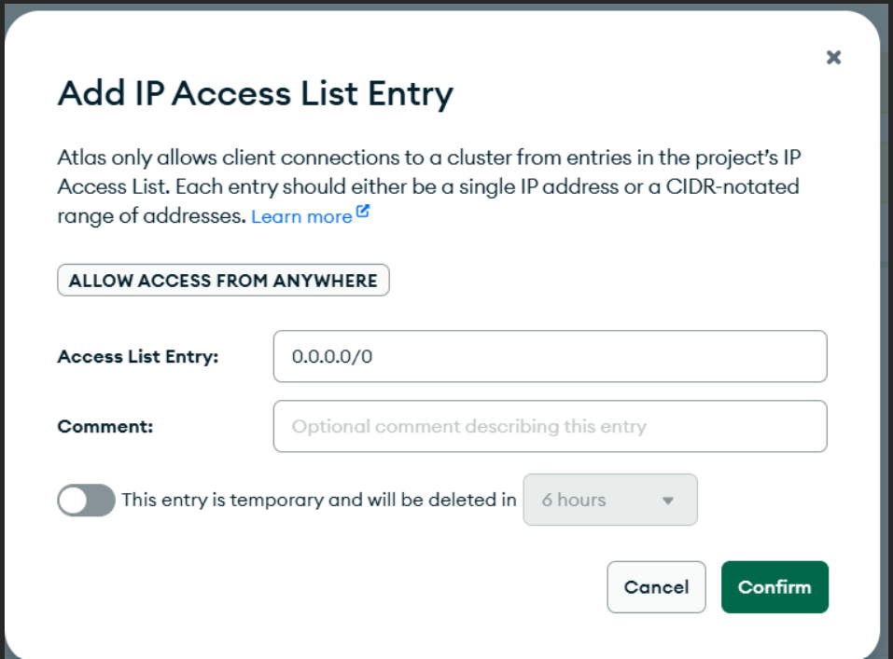

In Code I used Pymongo to load the preprocessed data with python to MongoDB atlas.
I also put 'revision' filed to each object to mention the schema version (That is a design pattern in MongoDB that is suitable for data analysis to access data based on the schema version).

Data analysis and visualization
Before doing visualization and analytics we had got data by executing MQL queries and befitted from MongoDB aggregation pipeline.

Then we did the following:

WordCloud
for reviews to detect common complaints or good things in hotels (we can detect the things that make people love and hate).
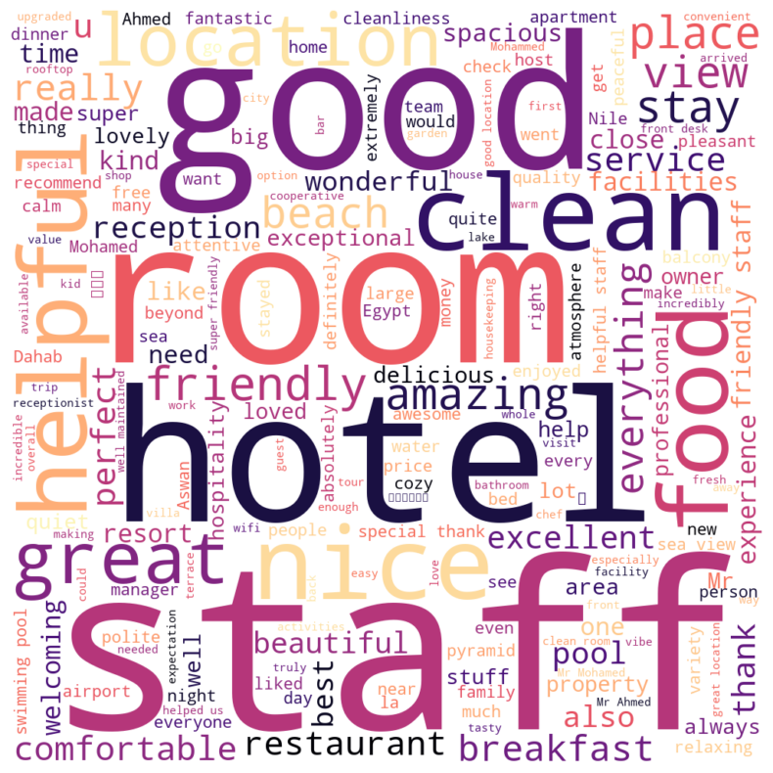
We removed stop words and make the plot.
We can derive that:
- The cleanliness of the hotel and Staff is important thing.
- Hotel owners should give attention to food and breakfast.
- People love hotels that have beach and swimming pools.
- Location is very important to hotel.

Number of hotels in each City
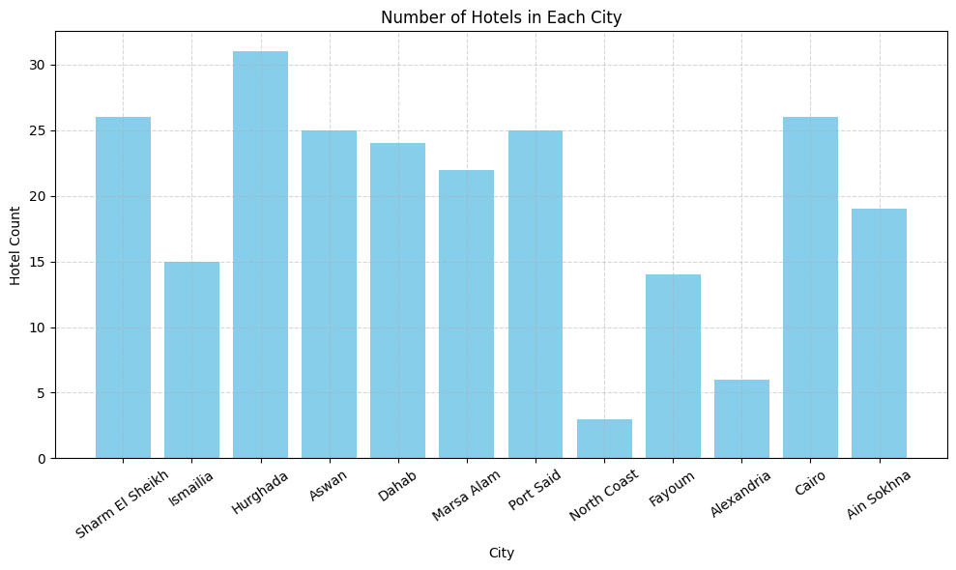
We can see that Hurghada, Sharm and Cario (Capital and coastal cities) have the largest number of hotels.

Compare the frequency of each facility and rating.
We do that to compare the effect to each facility on the rating.
We chose top 10 facilities by count.
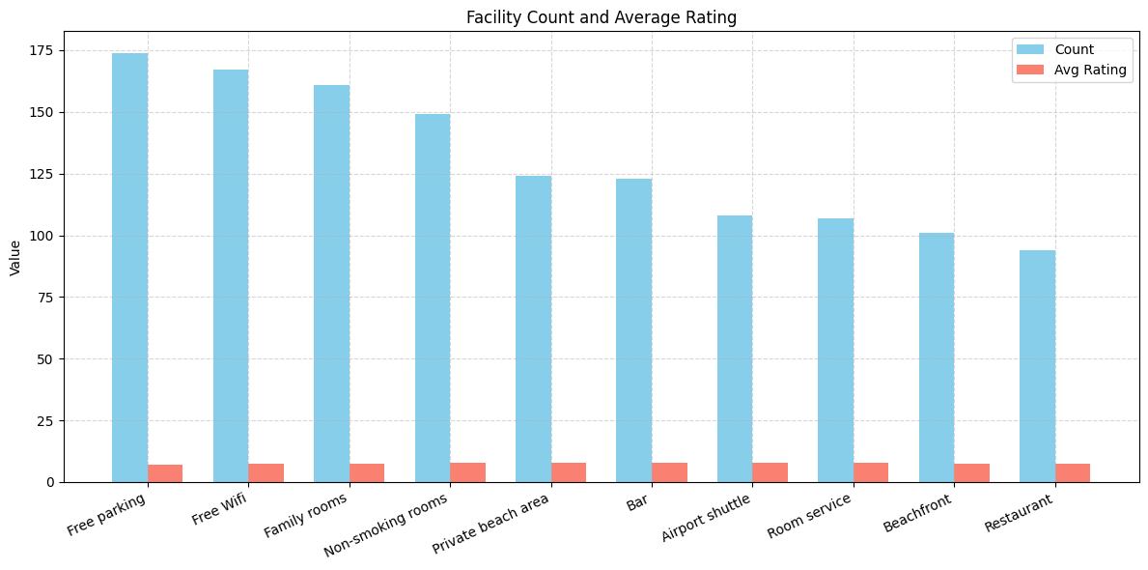

Frequency of more facilities with treemap:

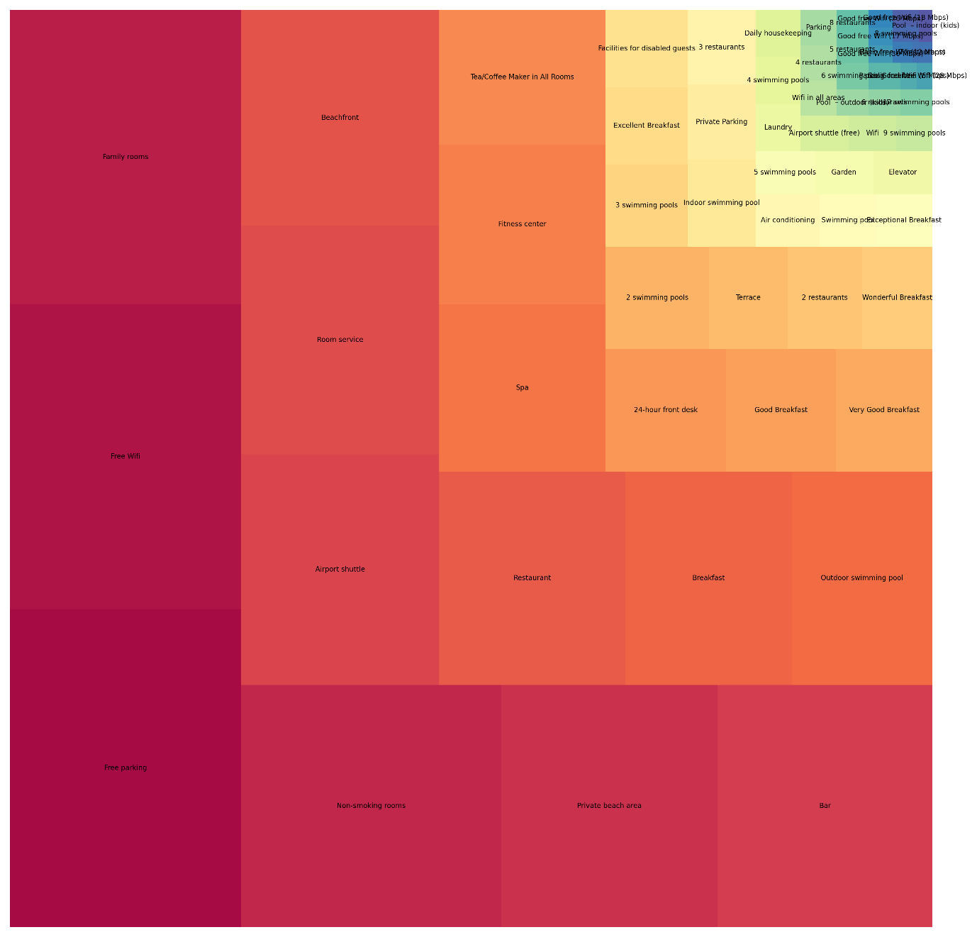
We can see the small effect of the most frequent facilities on rating:
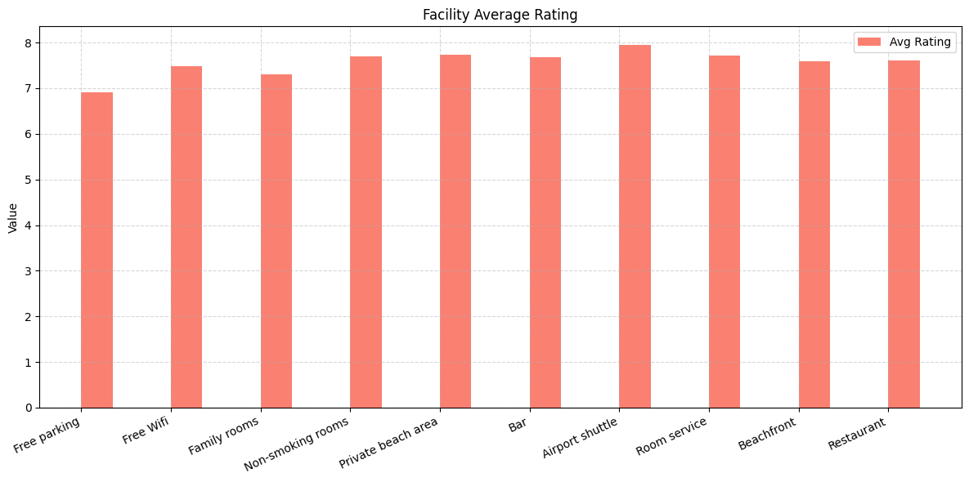

Radar Chart of each hotel to compare different metrics of ratings.
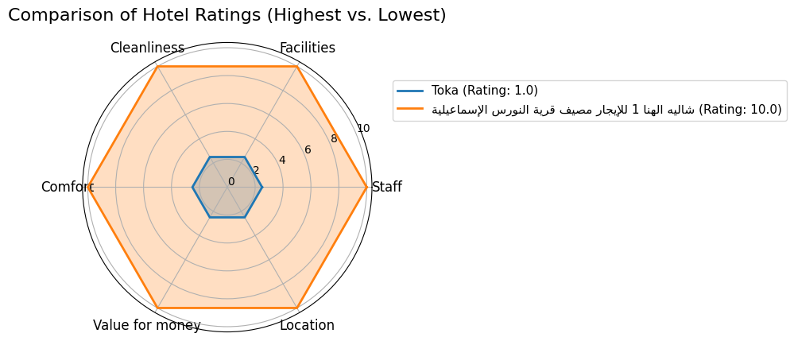

We compared the hotel with the highest ranting with the hotel with the lowest rating.

Some Correlations and relationships
We chose Price with rating.
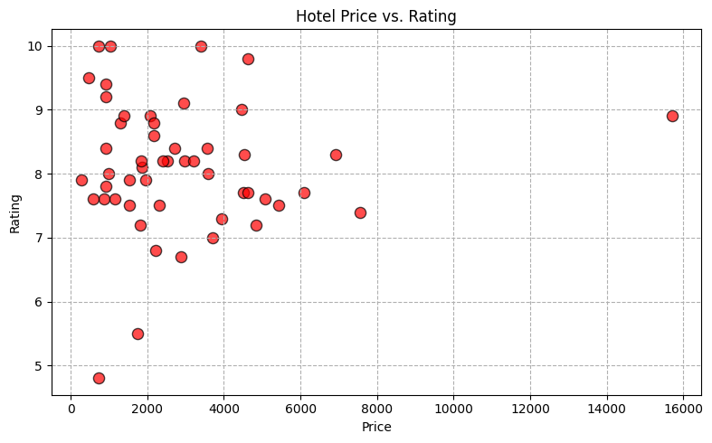
We can see It is slightly positively correlated.

Boxplot and histogram to see distribution and outliers in ratings.
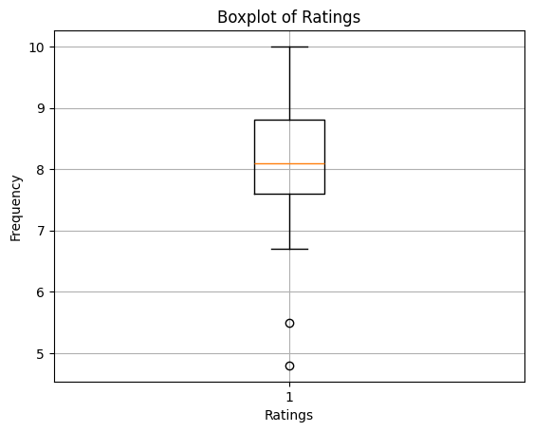
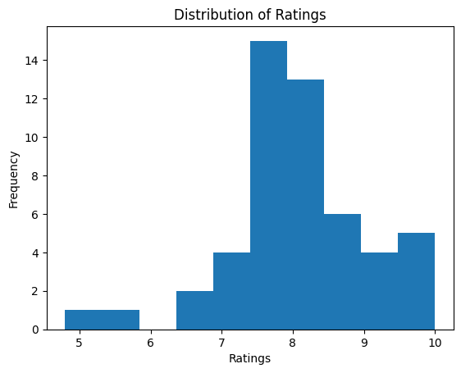
We can see the range of rating is high from 7 to 10 approximately.

Which countries leave the most reviews (Comments on the hotels)?
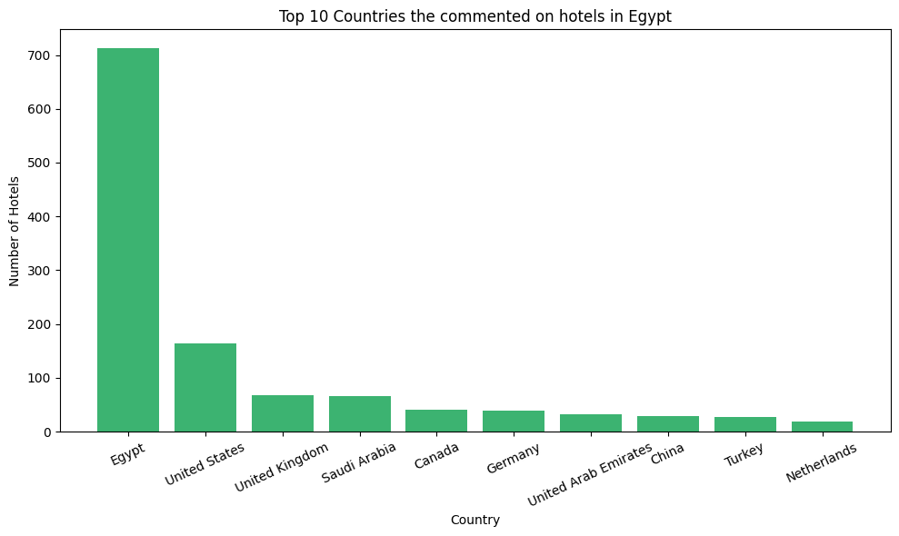
We can see the foreign countries that have the most visitors to Egypt.

Geographic heatmap to see rating for each governorate and number of hotels.

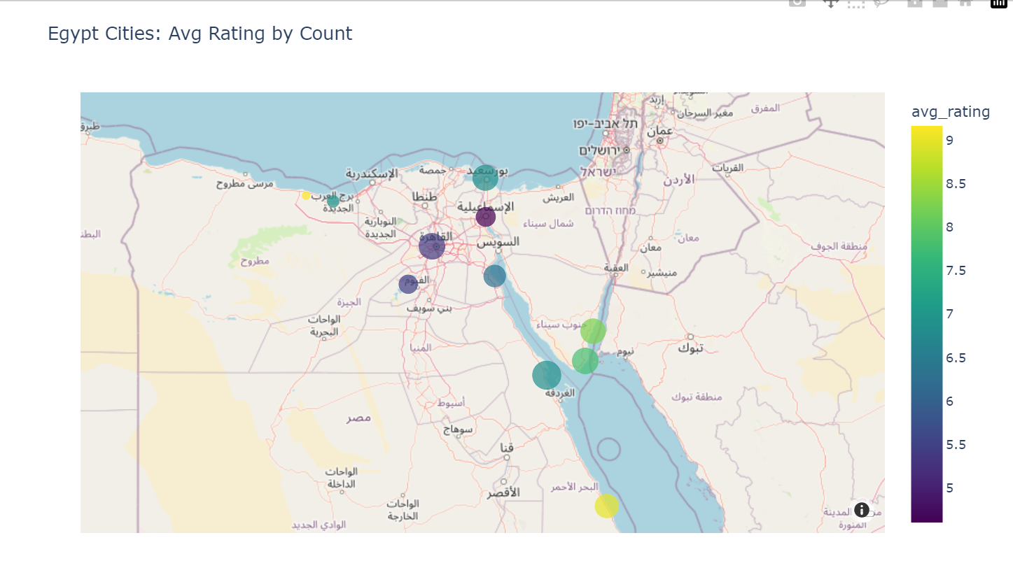
We can do the same for avg_price.
We deployed that to streamlit.
Some screenshots:
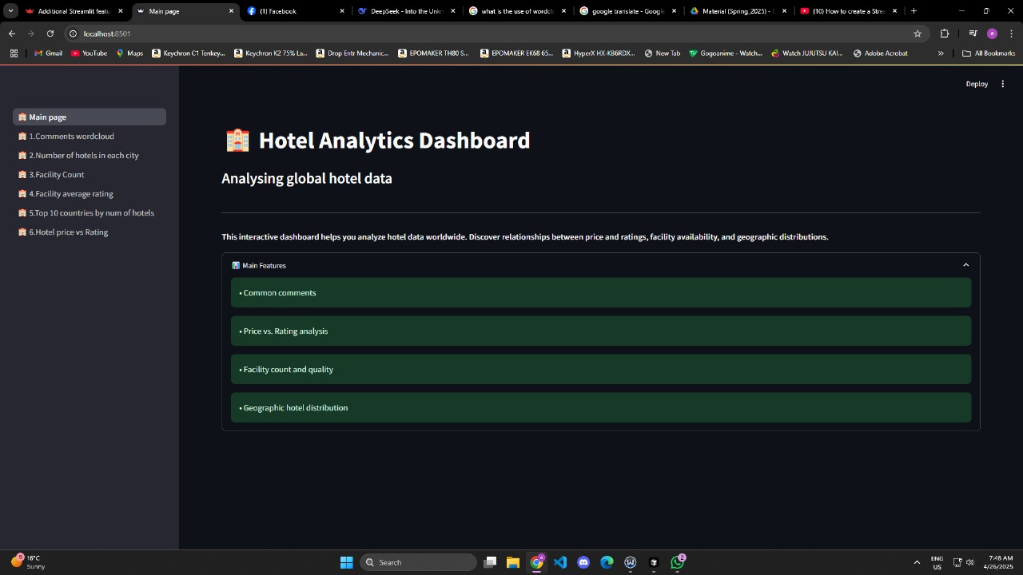
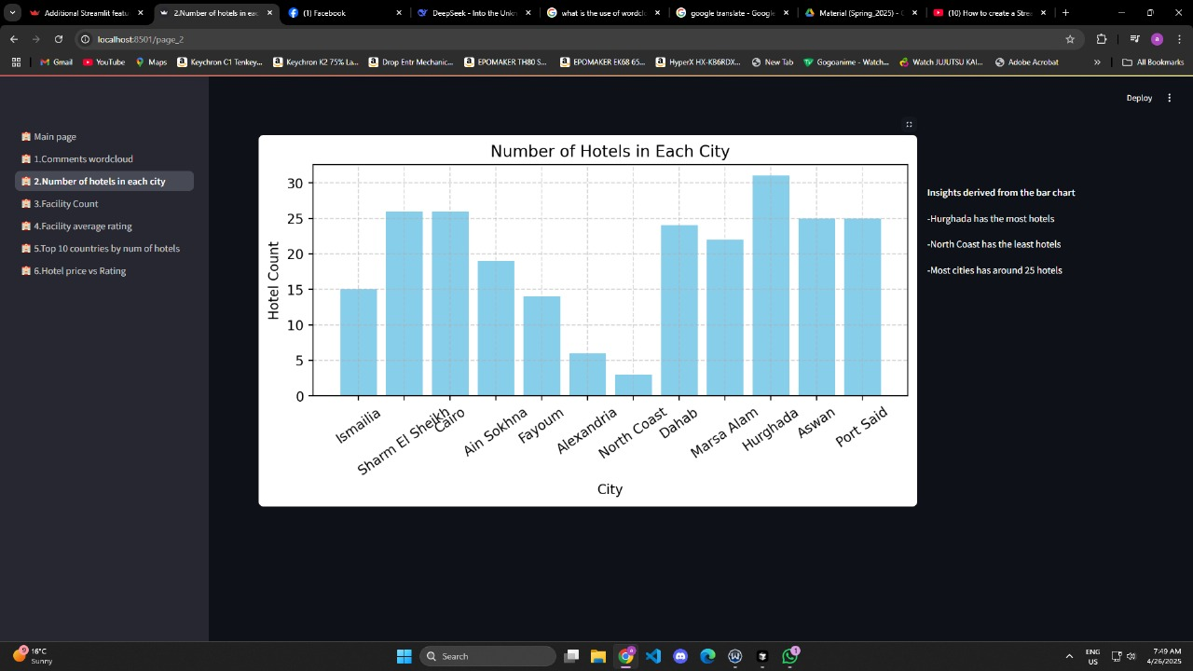
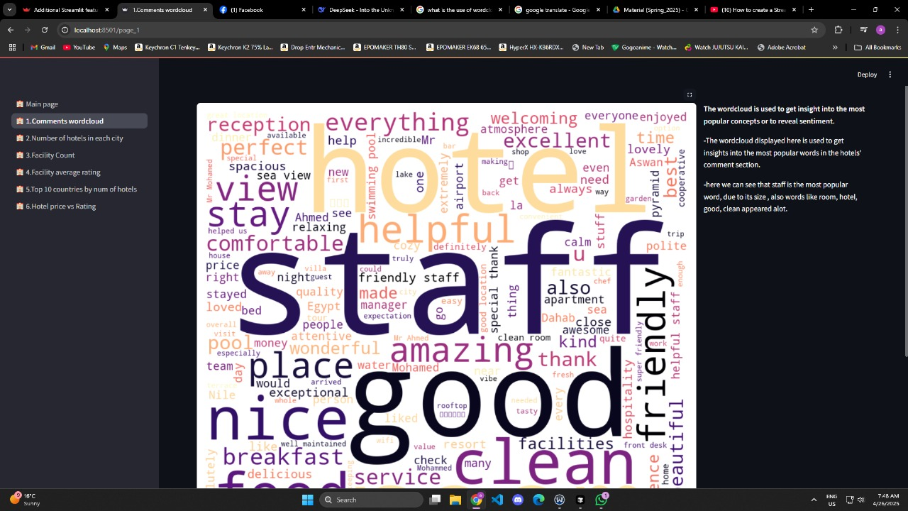
And the other plots are shown.

Thanks

